Project acronym:
PaNdata ODI

Contract n°: RI-283556

Project type: CSA-SA

Start date: 01/10/2011

Duration: 30 months

Total budget:
3 644 261 €

Funding from the EC:
1 950 000 €

Total funded effort in person-month:
315

Web site:
www.pandata.eu

Contact person:
Juan Bicarregui
email: juan.bicarregui@stfc.ac.uk
tel.: +44 1235 445710
fax.: +44 1235 445945

Project participants:
STFC UK
ESRF FR
ILL FR
DIAMOND UK
PSI CH
DESY DE
ELETTRA IT
SOLEIL FR
CELLS-ALBA ES
HZB DE
CEA FR

Keywords:
Photon, Neutron, Data, Metadata, Provenance, Preservation, Scalability

Collaboration with other EC
funded projects:
CRISP, EuroFEL, NMI3
xxxx
xxxx


PaNdata ODI
Photon and Neutron Data – Open Data Infrastructure - RI

Summary: The PaN-data collaboration brings together eleven large multidisciplinary Research Infrastructures which operate hundreds of instruments used by over 30,000 scientists each year. They support fields as varied as physics, chemistry, biology, material sciences, energy technology, environmental science, medical technology and cultural heritage. Applications are numerous, for example, crystallography can reveal the structures of viruses and proteins important for the development of new drugs; neutron scattering can identify stresses within engineering components such as turbine blades, and tomography can image microscopic details of the 3D-structure of the brain. Industrial users include the pharmaceutical, petrochemical and microelectronic industries. PaNdata-ODI will develop, deploy and operate an Open Data Infrastructure across the participating facilities with user and data services which support the tracing of provenance of data, preservation, and scalability through parallel access. It will be instantiated through three virtual laboratories supporting powder diffraction, small angle scattering and tomography.

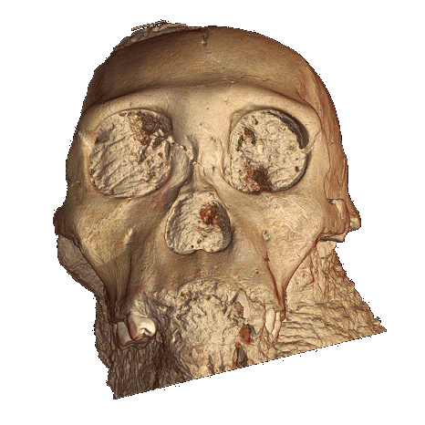
Objectives: The main goal of PaNdata ODI is the creation of a sustainable, federated data infrastructure for the users of its Neutron and Photon Sources. Building up on the foundation laid by PaNdata Europe, the project aims to deploy, operate and evaluate a generic catalogue of scientific data across the participating facilities and promote its integration with other catalogues beyond the project. The long preservation of highly valuable scientific data will utilize available standards like OAIS or HDF5/NeXus. A federated identity management system will underpin the provision to users of an integrated environment harmonized across the participating facilities. The services to be deployed by PaNdata ODI will allow the creation of virtual laboratories for selected applications to demonstrate the capabilities to a wide range of scientific communities. One such application is micro-tomography, a technique recently used to investigate the skull of the possibly oldest known human ancestor, an Australopithecus sediba child excavated in South Africa and curated by the Witwatersrand University (the illustration above shows a projection of the 3D-reconstruction of the skull).

Action plan: The project consists of eight work-packages, which span the entire data continuum from proposal, through data collection and analysis, to publication, archival and access, permitting to link together publications, primary scientific data and the software framework used to derive a scientific conclusion. The PaNdata consortium has already successfully co-operated for a number of years. The current project will further enhance the collaboration and aims to expand beyond the current consortium and the European research area, and strengthen the co-operation with related European projects including the ESFRI cluster project CRISP (WP2). Particularly the work packages on data preservation (WP7) and provenance (WP6) will strongly benefit from such projects fostering standardization and interoperability of data and metadata infrastructures. The creation of a cross-facility data catalogue (WP4) requires the unique and persistent identification and authentication of users across scientific disciplines and facilities (WP3). The combination of these activities will cumulate in a number of virtual laboratories to demonstrate the service in particular for the user communities (WP5).

Coordination and/or support activities: One goal of the project is to share existing knowledge between the partners, the users of their facilities and the wider scientific community. Building on the similarity of purpose and commonality of practice across the participating facilities, there are many areas of practice with regards to data handling where the formulation of a cohesive framework will be beneficial to the partners, similar organisations, and the scientists using them. The aim of the Service Activities is to deploy and operate a common set of services for catalogued access to scientific data which provide provenance information and managed preservation and which, in turn enable the development of new services across raw, analysed or published data which will be the real scientific merit. Given the fact, that there is a significant overlap of users and scientific applications, such commonality is high on the priority list for facility users.

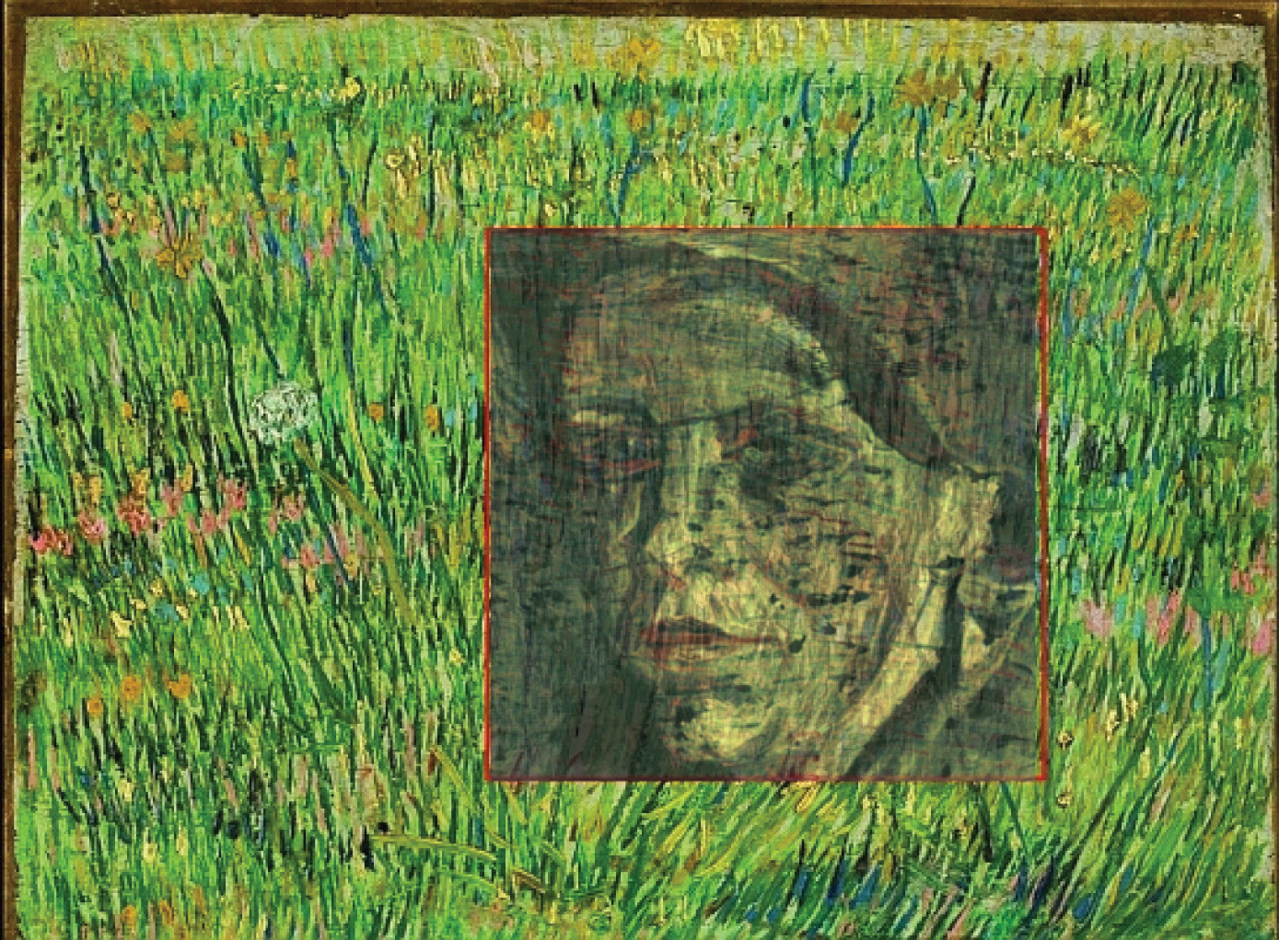
User communities: Users of Neutron or Photon facilities encompass a wide variety of different scientific communities ranging from arts and humanities over structural biology to material sciences or plasma physics, to name a few. However, all facilities have platforms to communicate and interact with the users and user organizations like annual user meeting or direct user support at the facilities.
The illustration on the right provides an example of the use of synchrotron radiation to discover a hidden van Gogh painting by fluorescence spectroscopy, which became only possible by exploiting a tight co-operation between the user and the scientists providing support at the experimental station. The main focus hence lies in the utilization of these communication platforms, the coordination of these activities and the involvement with related projects like for example BioStruct-X, NMI-3 or ELISA/ESUO.

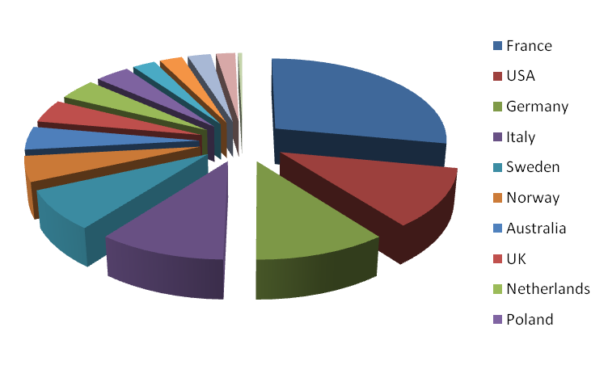
International aspects: PaNdata ODI will have an impact on sharing of and access to scientific data well beyond the consortium and Europe. The users of the Neutron and Photon Sources commonly use more than just a single facility and often utilize both Neutrons and Photons to investigate a scientific problem in small, but volatile and distributed, collaborations. The figure on the right shows a typical example, the international collaboration profile of Swiss users of the European Synchrotron Radiation Facility (ESRF). User identification and authentication hence need to be internationally applicable. Another aspect with an international impact concerns standardization of data and metadata formats. PaNdata will base developments on such international standards, and further develop them towards high-speed capabilities in close cooperation with standardization bodies like the NeXuS International Advisory Committee (NIAC).

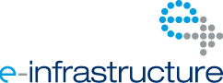

Photon and Neutron Data – Open Data Infrastructure - RI

